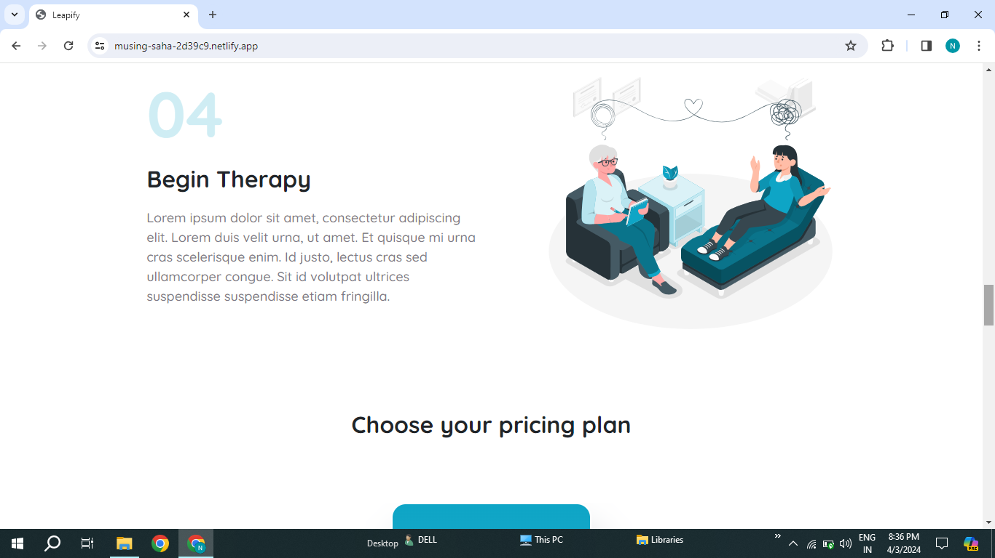

1.It Should be understandable English language

2. “Y, P, P” should be capital from your pricing plan